Optimization of Inventory Management for Ronak Super Market.

BDM Capstone Project Mid-term Submission

Name :- Aniket Nagdare

Email Id :- [aniketnagdare2002@gmail.com](mailto:aniketnagdare2002@gmail.com)

|  |  |
| --- | --- |
| **INDEX** | |
| **TOPIC** | **Page No.** |
| Executive Summary | 2 |
| Proof of Originality | 2 |
| Metadata and Descriptive Statistics | 3 |
| Analysis processes and methods | 7 |
| Results and Findings | 8 |
| Appendix – Proof of Originality | 9 |

# Executive Summary

Grocery shopping plays an essential role in daily life, impacting our well-being and nutrition. From a business perspective, proactive planning, robust customer relations, and strategic thinking are crucial for establishing a strong market position in the grocery sector.

Ronak Super Market, a medium-sized kirana store, currently faces challenges in profit and inventory management, indirectly affecting its net profit and sales. The rise of online shopping has introduced significant changes, posing additional hurdles for local stores like Ronak Super Market, resulting in declining profits. This project aims to tackle these unique challenges by focusing on understanding cash flow dynamics and optimizing inventory control. Through rigorous data analysis, our goal is to provide practical solutions that enhance Ronak Super Market 's overall performance.

The project will utilize tools like Microsoft Excel for data analysis and visualization. The data types involved include historical sales data, inventory levels, and purchase orders. Data collection will span the past one month to ensure a comprehensive analysis.

## Goals for the Mid-Term Include:

* Identifying high-contributing SKUs(**Stock-Keeping Units**) for sustained sales.
* Determining SKUs with the highest profit margins.
* Applying the Pareto Principle to prioritize SKU management.
* Analyzing market trends in revenue and purchase prices.

# Proof of Originality

## Details :

**Name :** Ronak Super Market

**Owner :** Mr. Ramesh Choudhary

**Address :** Kakade Park , Keshav Nagar, Chinchwad, Pune. 411033

## About :

Ronak Super Market has established itself as a leading kirana shop, serving a diverse clientele. Since its inception in 2015, Ronak Super Market has built a strong reputation for offering high-quality everyday essentials such as Dal, Sugar, Salt, Oils, Ghee, and Dry Fruits. Its commitment to quality and competitive pricing has made it a preferred choice among local shops and food establishments in the community. Ronak Super Market is also recognized for its proficiency in handling bulk orders, ensuring seamless service and customer satisfaction for parties and functions. This reputation underscores Ronak Super Market’s role as a dependable supplier of essential goods, catering to both retail and wholesale needs with excellence.

To establish the authenticity of the data, the supporting evidence as listed below:

1. **Images of Organisation :** These visuals are enclosed within Appendix , located on page 9. They can also be accessed through the G-Drive link:

[ [Drive Link](https://drive.google.com/drive/folders/1mEJ8UhaHUHJ9jVcpyVS71pG0wIpxkfUk?usp=sharing) ]

# Metadata and Descriptive Statistics

**METADATA:**

I have diligently collected a detailed dataset spanning 31 days, starting from June 1st to July 1st, 2024. My approach involved daily visits to the shop, supplemented by strategically timed alternate-day visits. This method enabled me to compile a comprehensive and cumulative dataset covering the entire period.

Data Can be access by following link :

[ <https://drive.google.com/drive/folders/1VtS5SCye5gHFtp4_WmP8w-XdZKJtvd4F?usp=sharing> ]

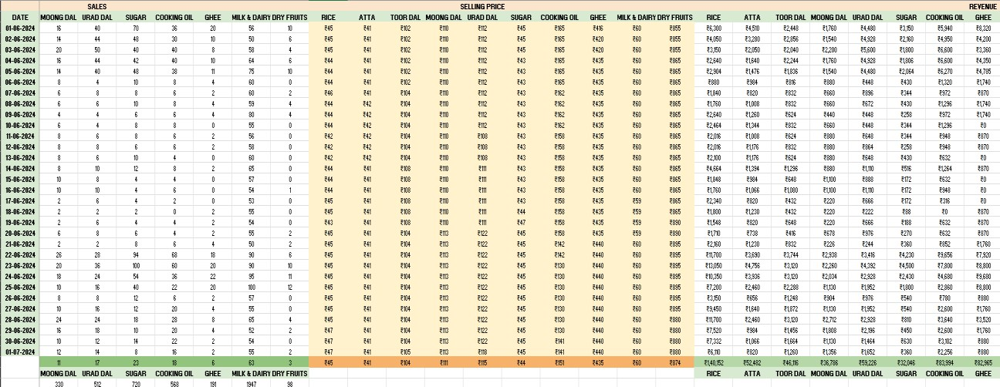

* 1. Preview of Collected Data

Here is the descriptive statistics analysis conducted based on the collected data :-

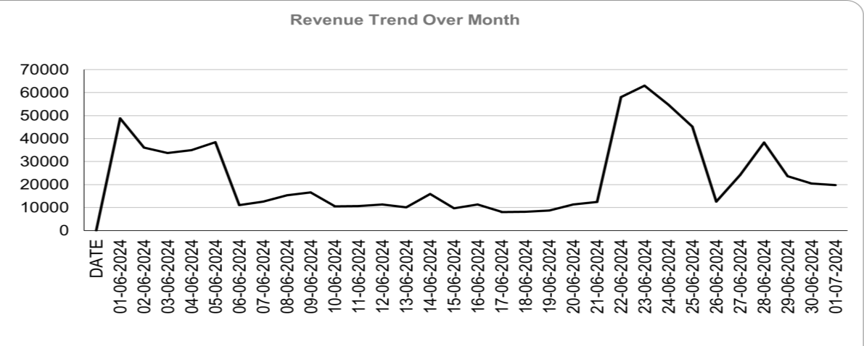

* 1. Total Revenue Trend observed over a month

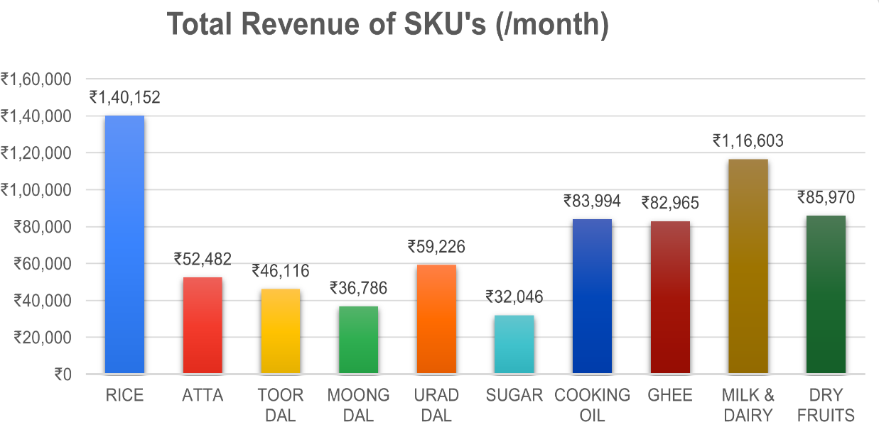

* 1. Total Revenue of all the SKU’s over a month

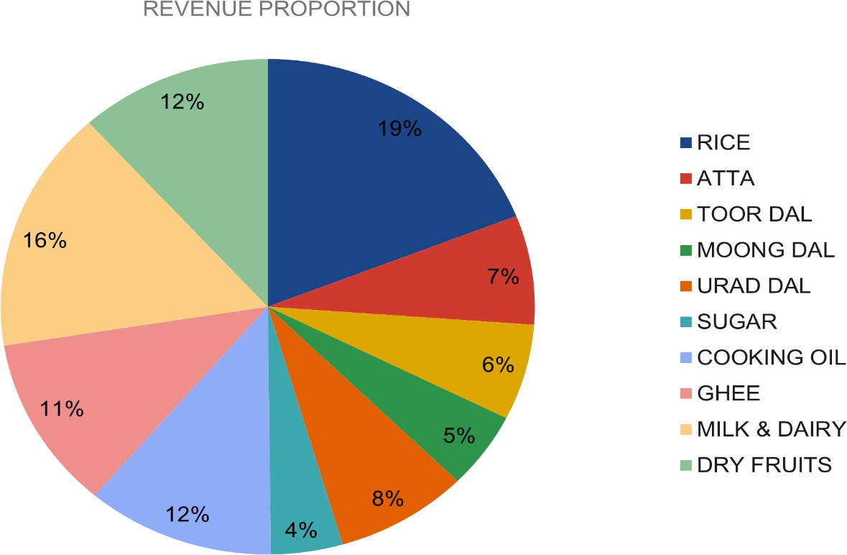

* 1. SKU’s proportion to Total Revenue

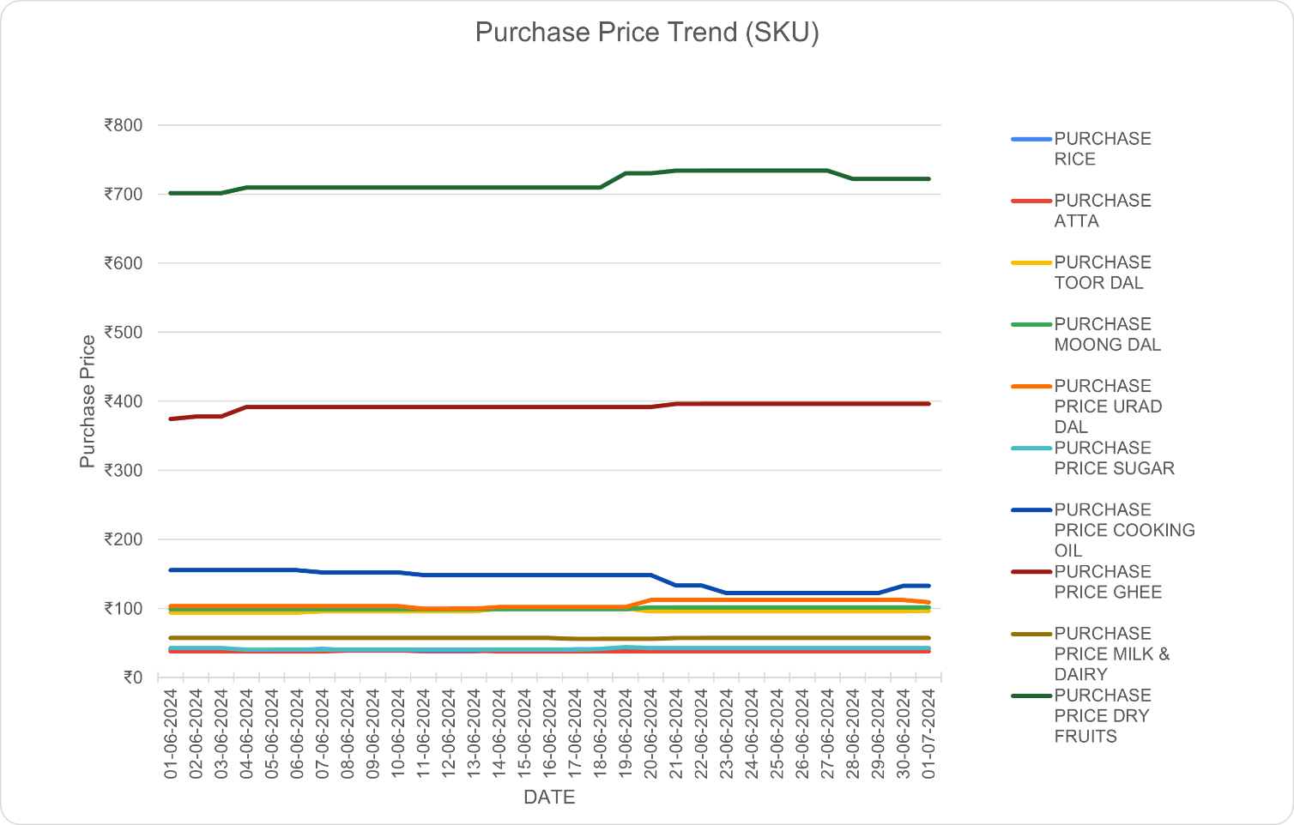

* 1. Purchase Price of all the SKU’s over a period of month (for shop owner)

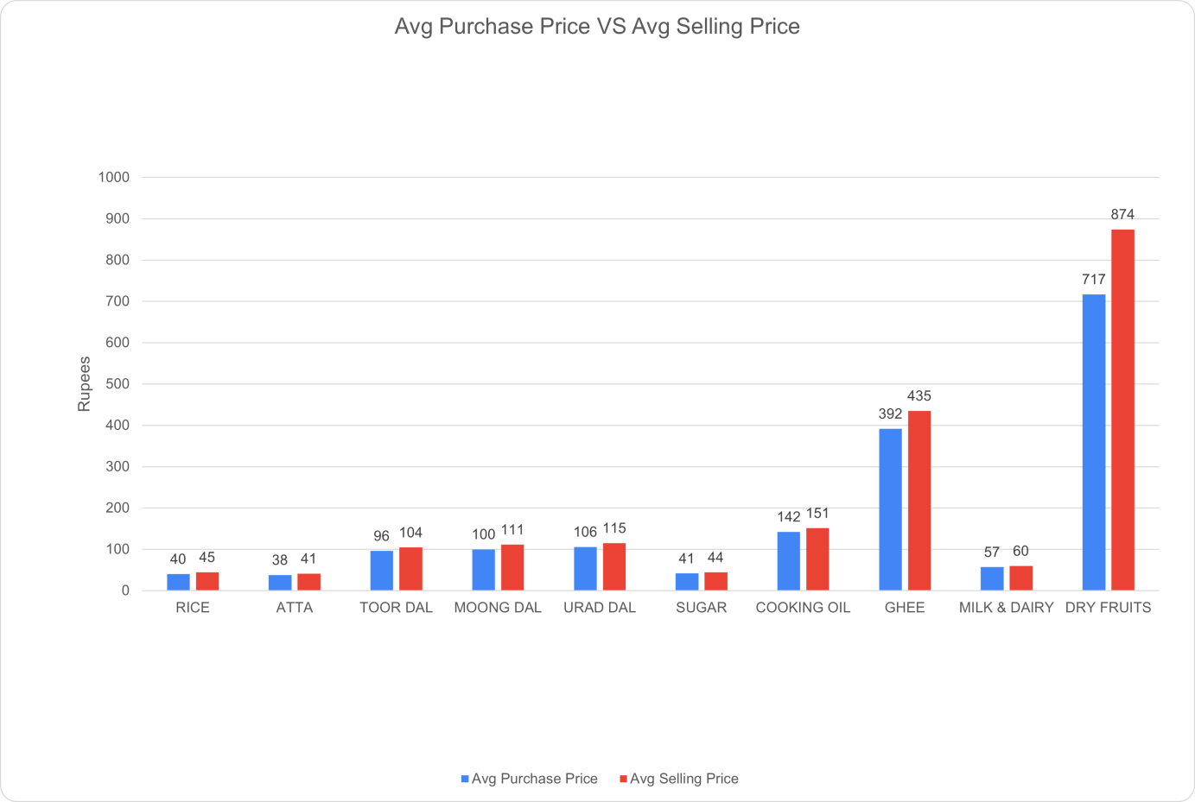

* 1. Avg. Purchase Price vs Avg. Selling Price

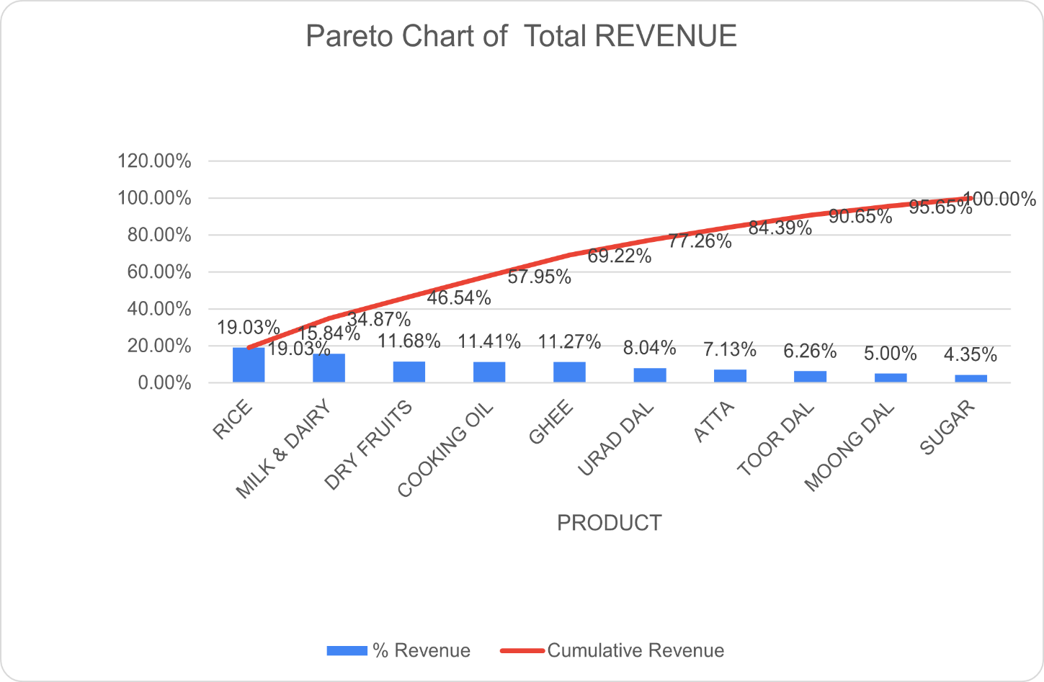

* 1. Pareto Chart of Total Revenue

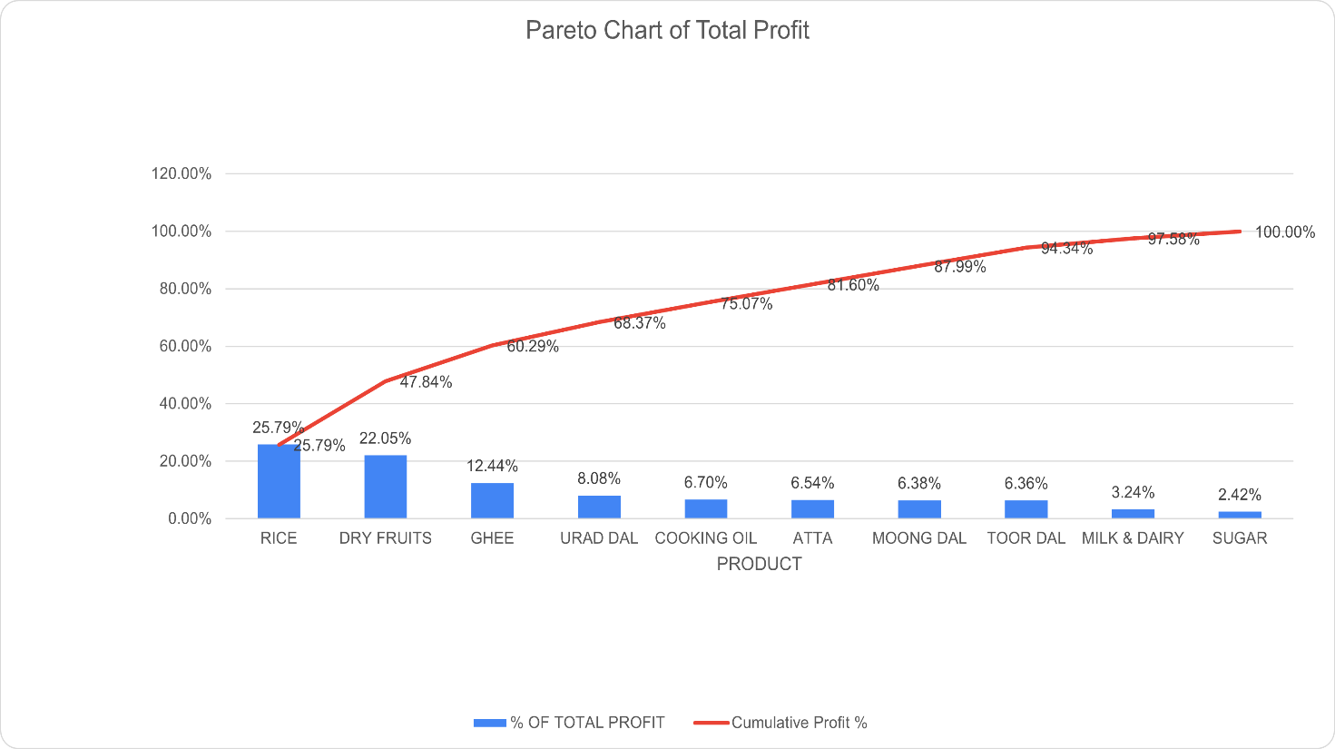

* 1. Pareto Chart of Total Profit

# Analysis processes and methods

Over a span of 30 days, I meticulously gathered and organized data in Google Sheets, ensuring its cleanliness and structure were optimal for analysis. This involved thorough checks for inconsistencies, missing values, and outliers that could influence results. Once prepared, I applied various descriptive statistical techniques such as calculating mean, average, profit margins, and inventory stocks to provide a comprehensive overview of the shop's operations.

To visually represent the data, I utilized a range of charts including column, bar, line, and pie charts. These charts effectively summarized metrics such as revenue, SKU profits, purchase prices, and their respective distributions. They not only provided clarity on performance but also identified trends and patterns critical for decision-making and strategic planning.

One of the key tools used was the Pareto Chart, which combined both bar and line chart elements. This chart methodically showcased the cumulative contribution of each SKU to overall revenue or profit. By sorting SKUs in descending order of their individual contributions and overlaying a line chart depicting cumulative percentage, the Pareto Chart highlighted significant contributors and strategic focal points.

For analyzing profit proportions across SKUs, I employed pie charts. These charts visually depicted the relative contribution of each SKU to total profit by dividing a circular graph into slices, with each slice proportional to the profit generated by a specific SKU. This clear visual representation facilitated quick understanding of profit distribution and key contributors.

Furthermore, trends over time in revenue and purchase prices were effectively displayed using line charts. This graphical representation provided a clear visual insight into how these variables fluctuated over the 30-day period, aiding in understanding seasonal variations or emerging patterns that could impact business strategies.

In conclusion, through rigorous data cleaning, descriptive analysis, and effective visualization techniques, I gained valuable insights into the dynamics of the business. These insights will guide informed decision-making and enable optimization of strategies to enhance overall business performance and profitability.

# Results and Findings

Based on the analysis of the graphs and charts, several key insights have surfaced:

1. **RICE Dominance in Profitability**: RICE emerges as the primary profit driver for Ronak Super Market. Its consistent contribution is underscored by a stable purchase price throughout the observed month, solidifying its essential role in the inventory despite challenges in cost reduction.
2. **DRY FRUIT's Profit Margin Leadership**: Among all SKUs, GHEE stands out with the highest profit margin. This indicates that while RICE leads in overall profit generation, DRY FRUIT offers substantial profitability relative to its cost.
3. **Pareto Analysis of Profit Contribution**: Applying the Pareto Principle reveals that a select few SKUs—specifically RICE, DRY FRUIT, GHEE, URAD DAL, OIL, and ATTA—contribute significantly, accounting for approximately 80% of the total profit. This highlights the concentration of profitability among key products.

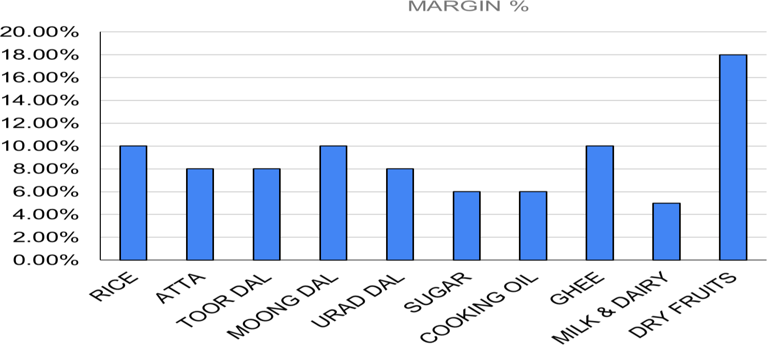

**( % Profit Margin )**

# Appendix A: Proof of Originality

**Images related to organization :**

